Sol Graph Evaluations
Noah Hoblet
6/15/2026

Example Graph Evaluations, as Taken From Sol 32
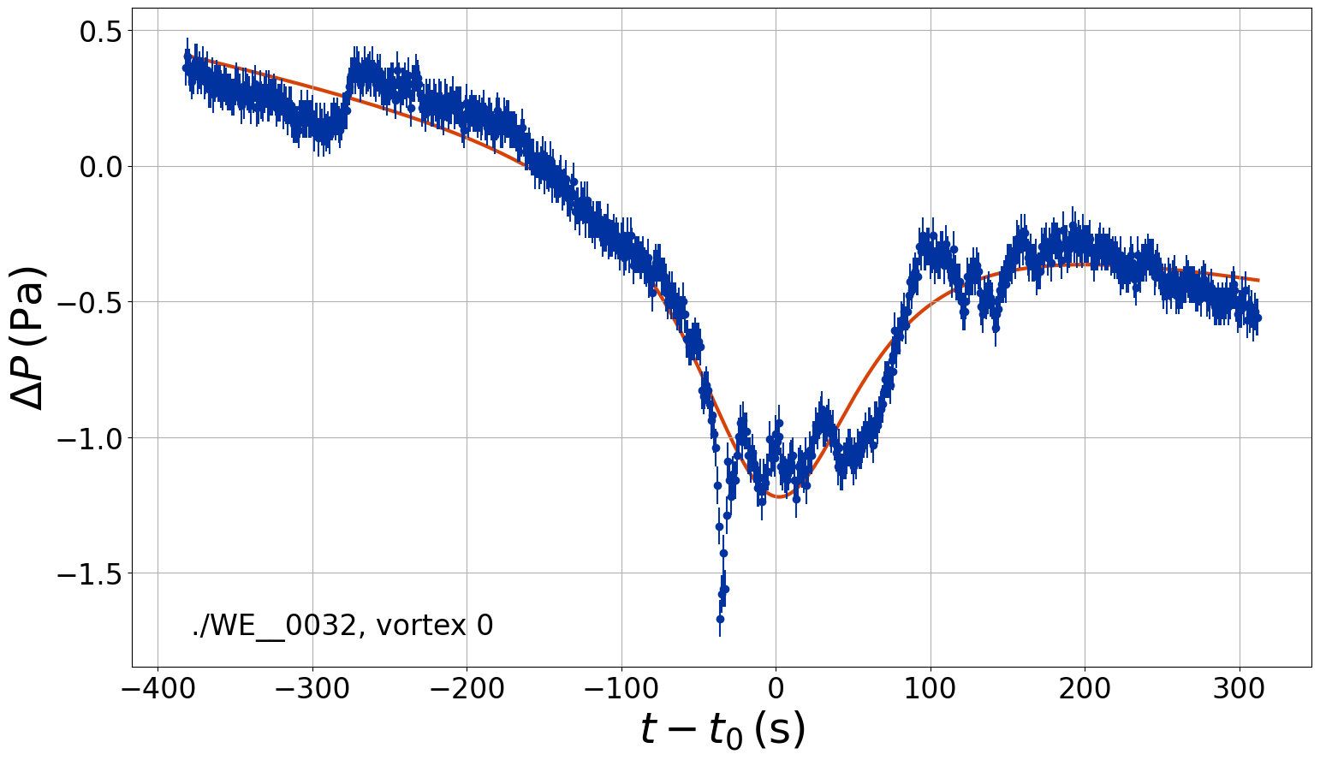
Solid detection with adequate numbers of data points, centering for context, and a parabolic pressure drop shape.

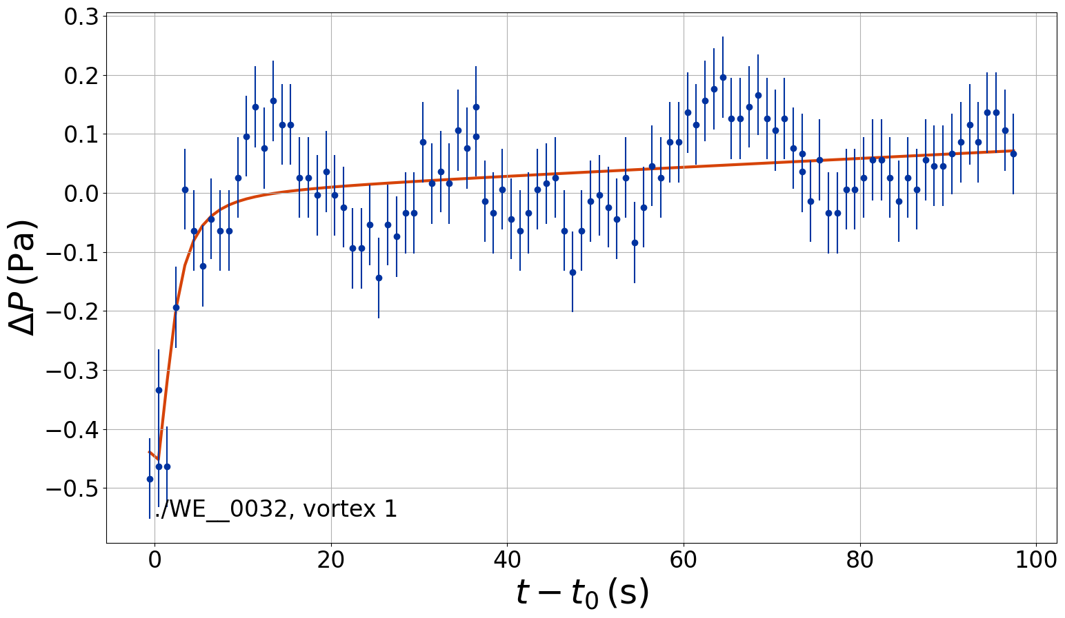
Very bad detection as well, the data is very noisy, and the left hand dip does not allow enough context into this potential vortex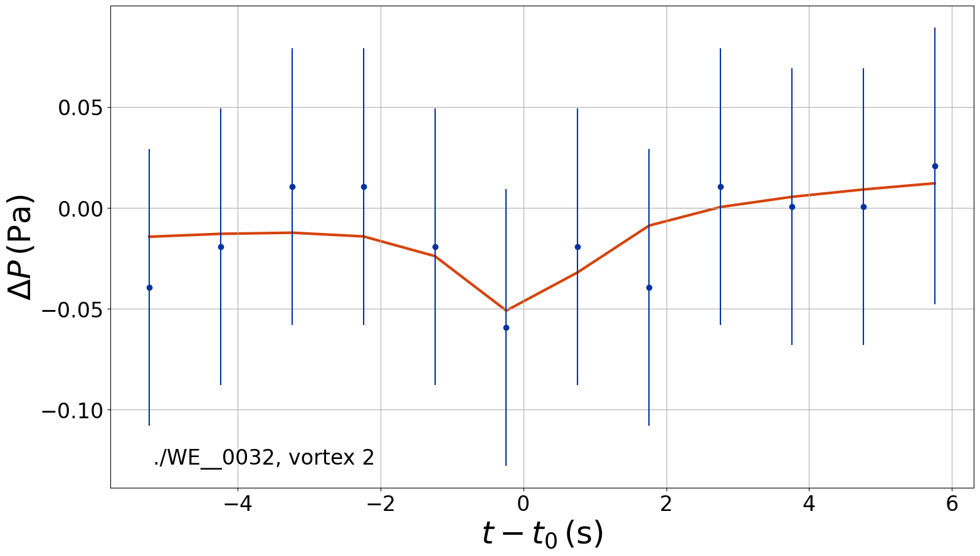
Bad detection as well, there are not enough points to operate on
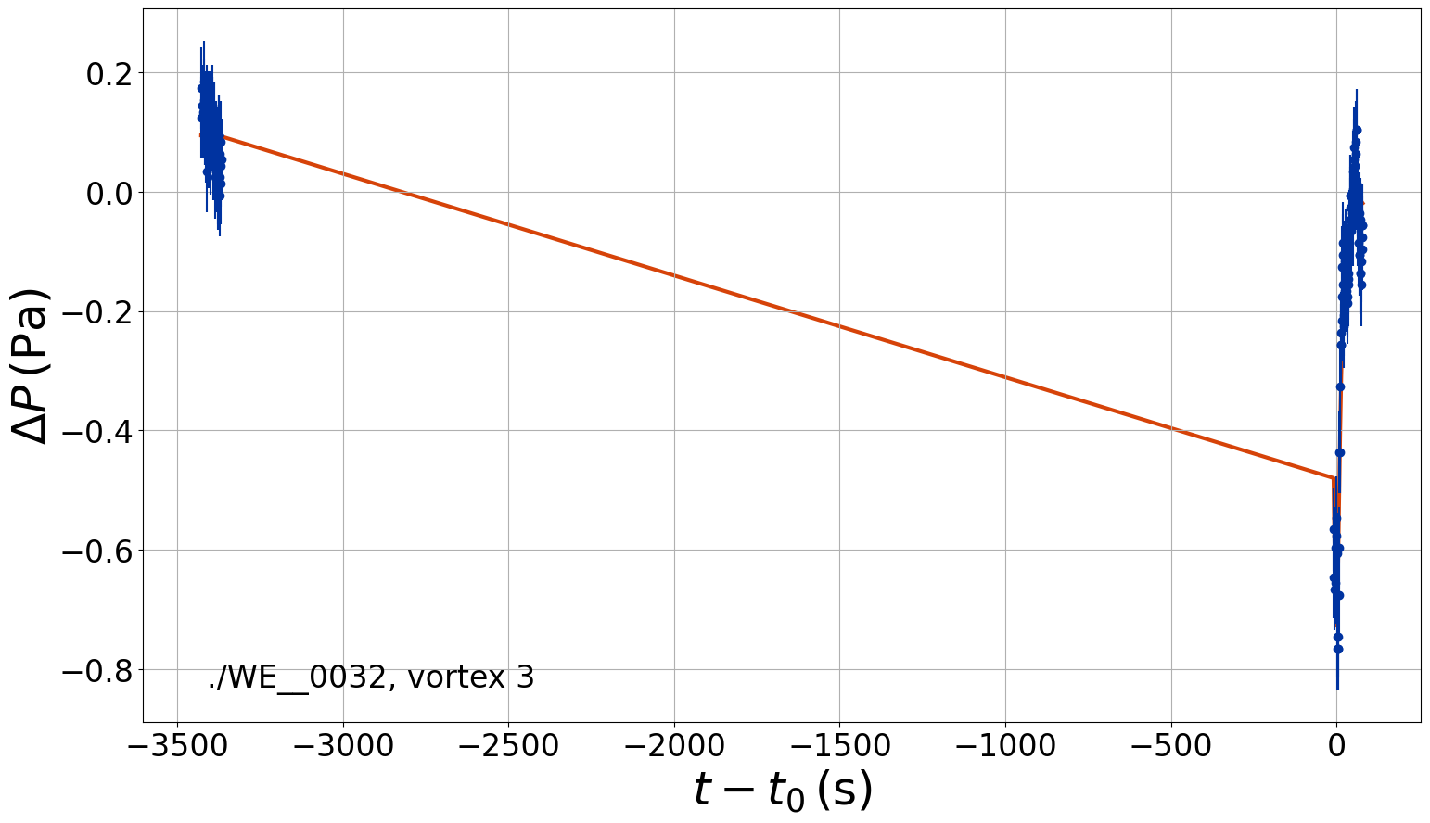
Very bad detection, the data is horribly gapped and cannot be considered reliable
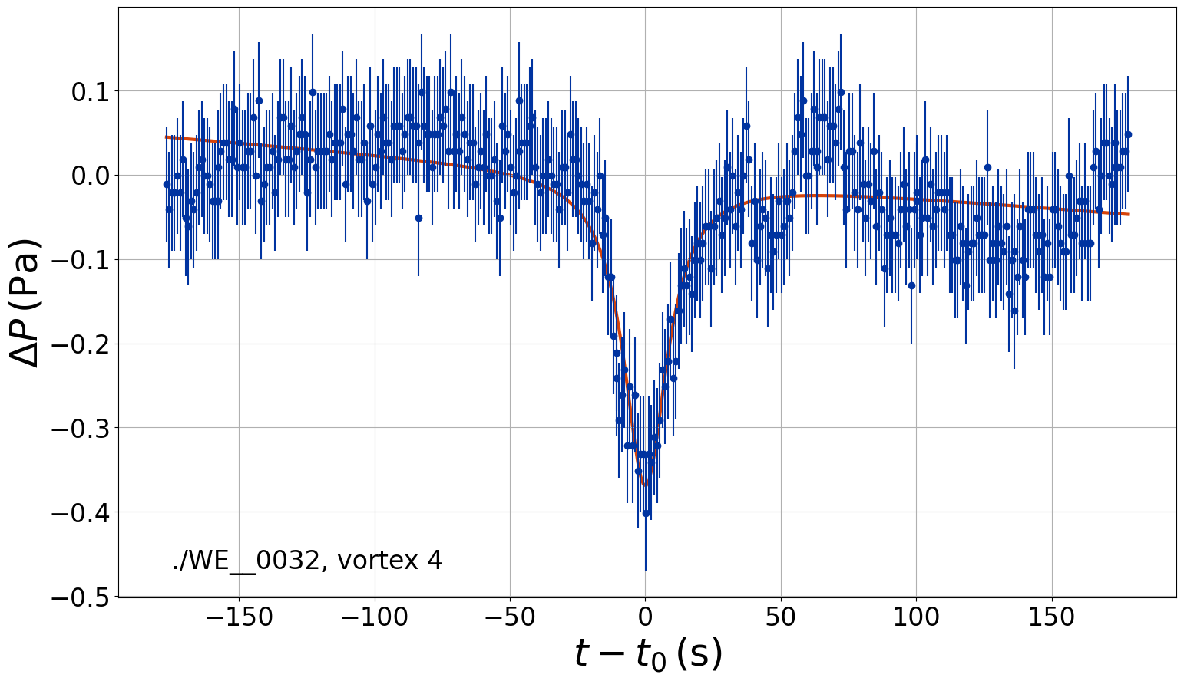
An ugly detection, with a great deal of noise, but it could be considered operable.

Evaluation of Self-Fetched Graphs

Sol 222
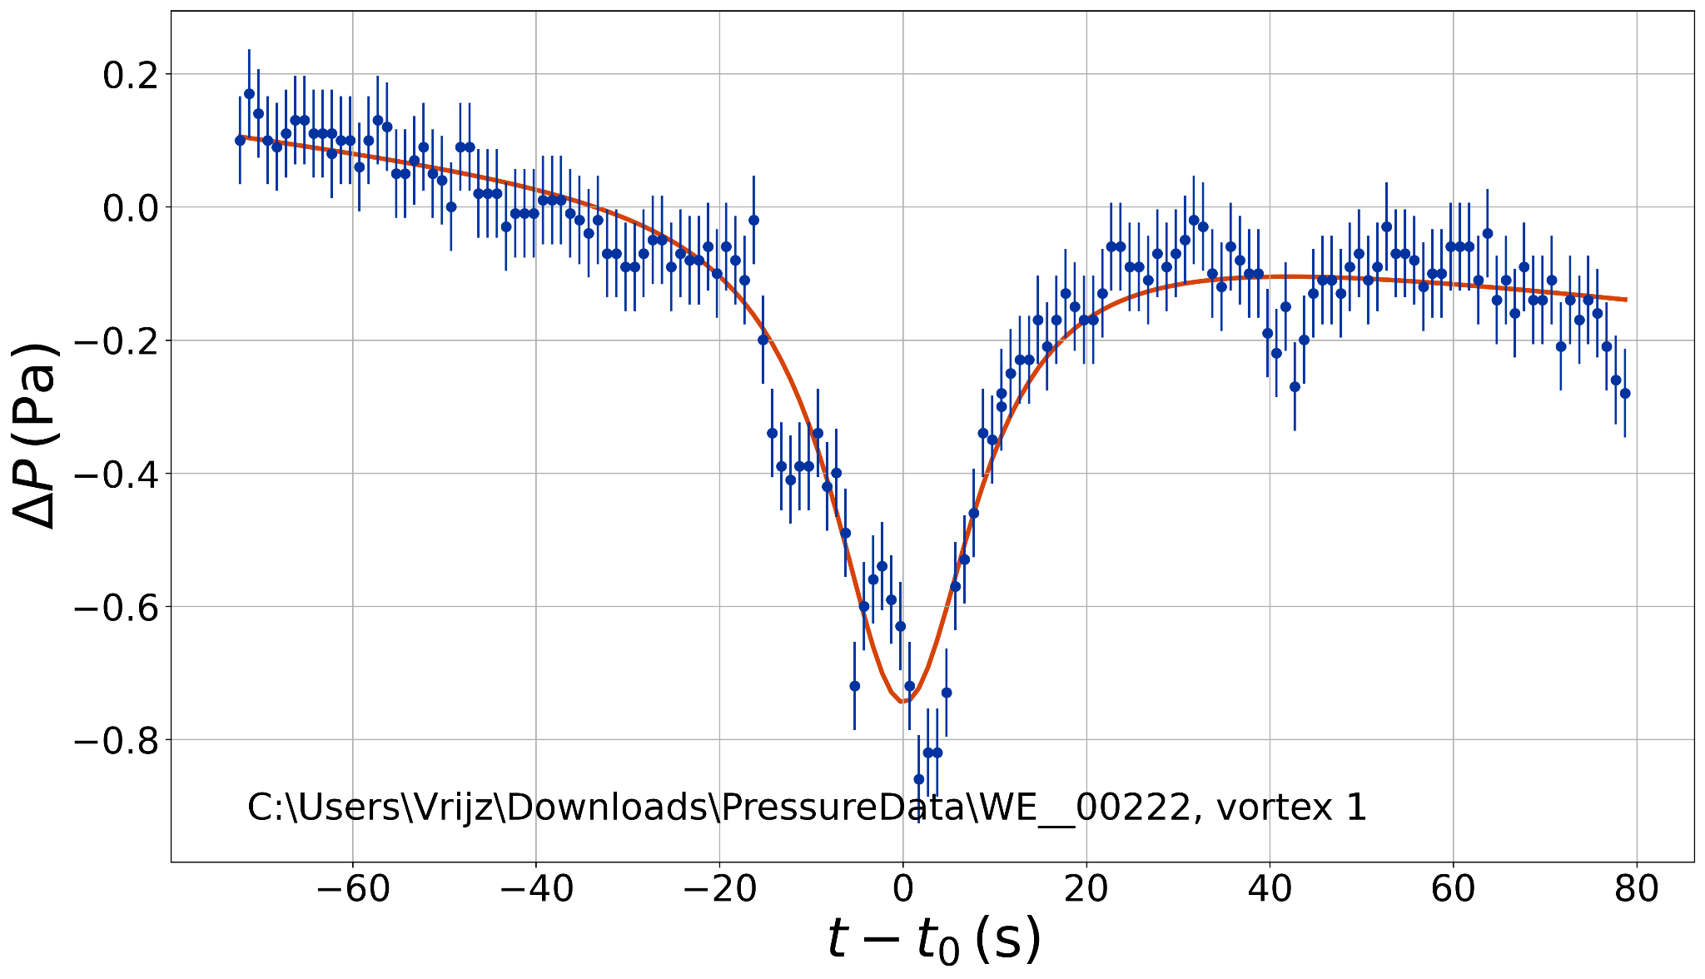
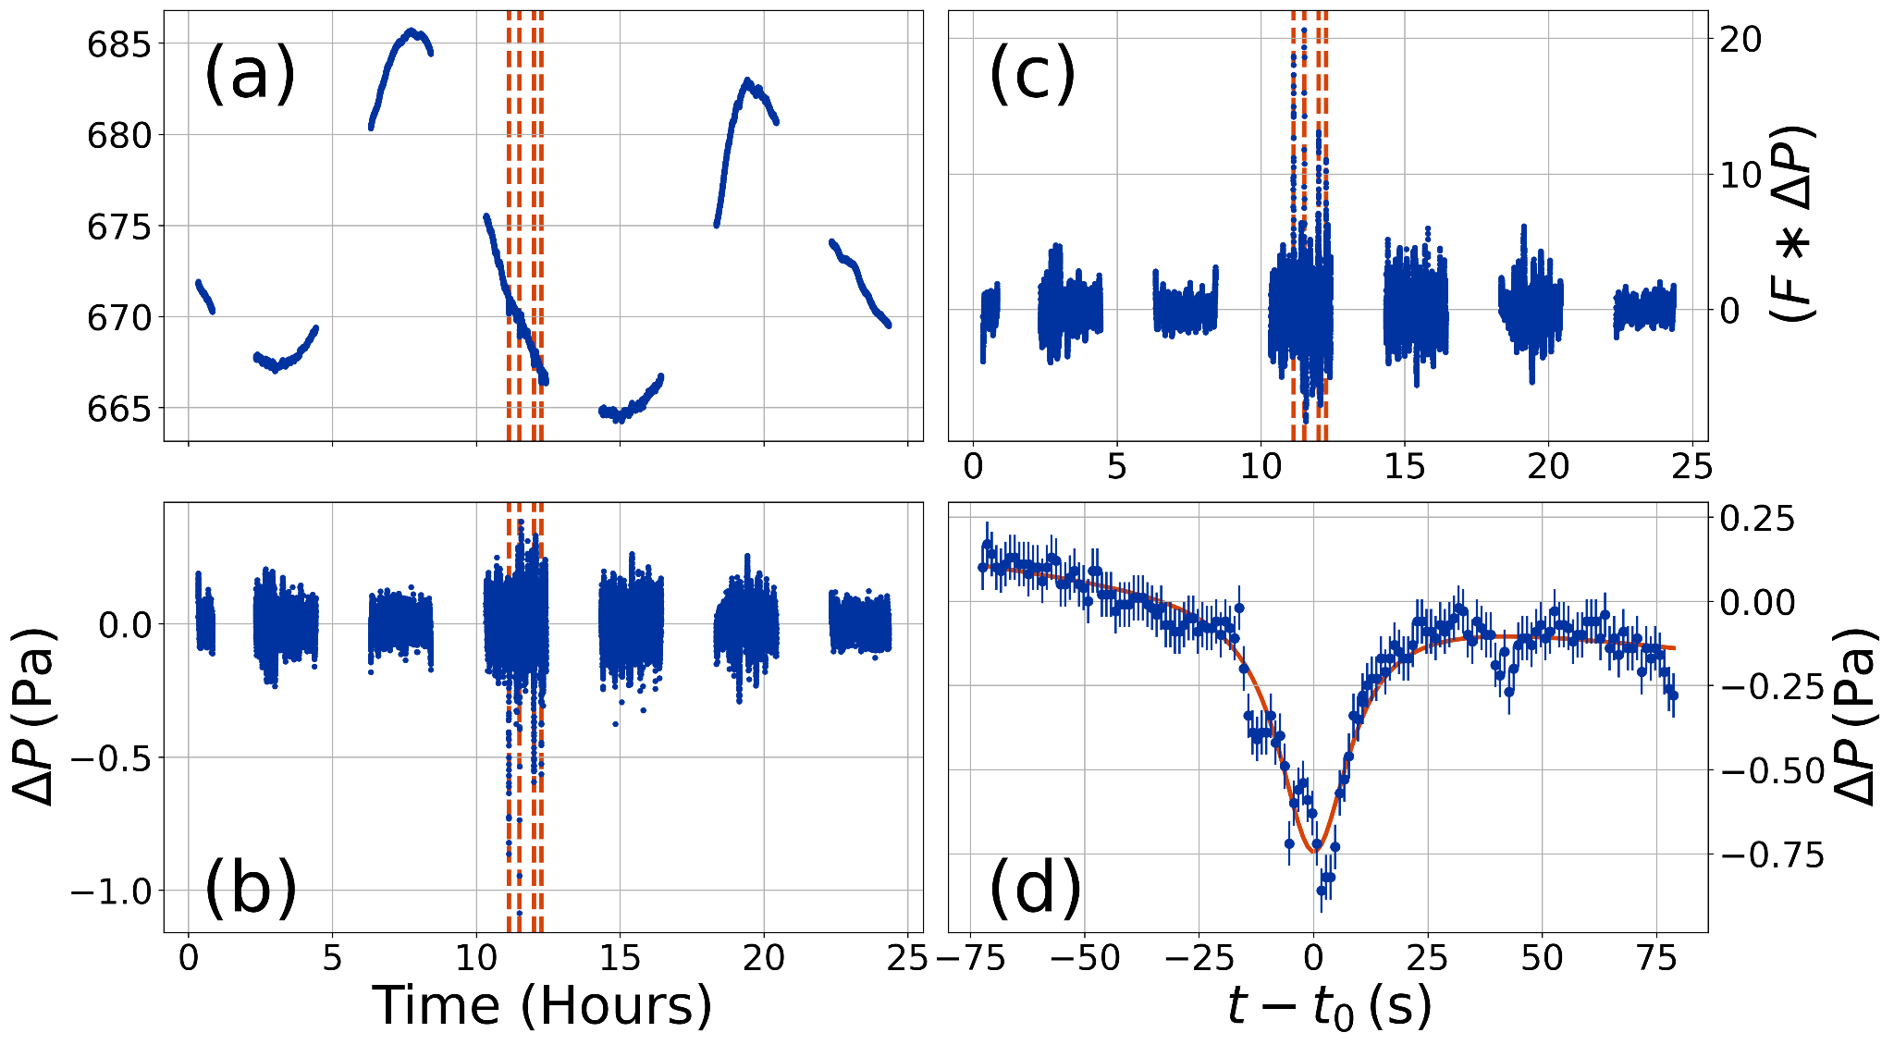Sol 787

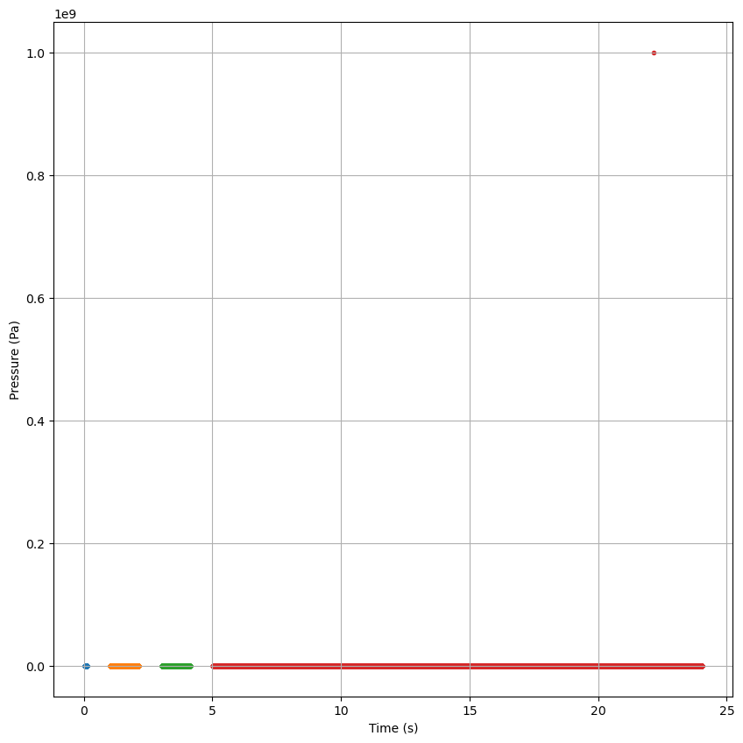
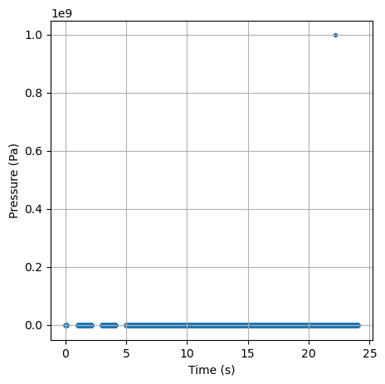
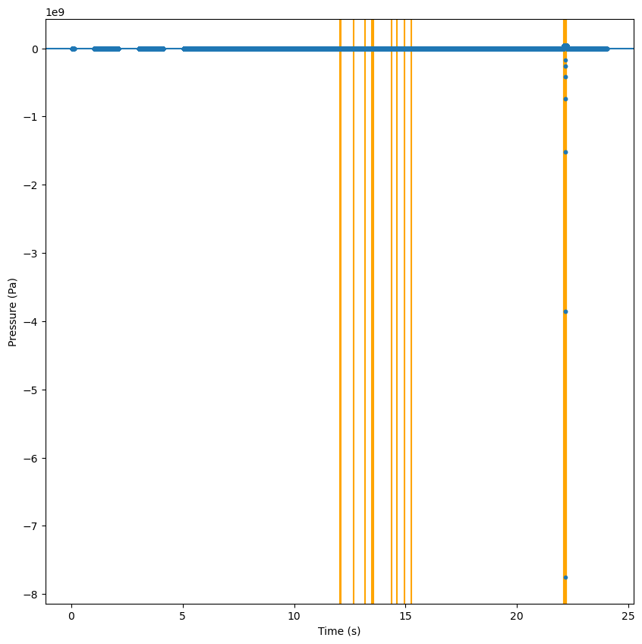
Numerous issues with data

Sol 1122
- 6 Vortices
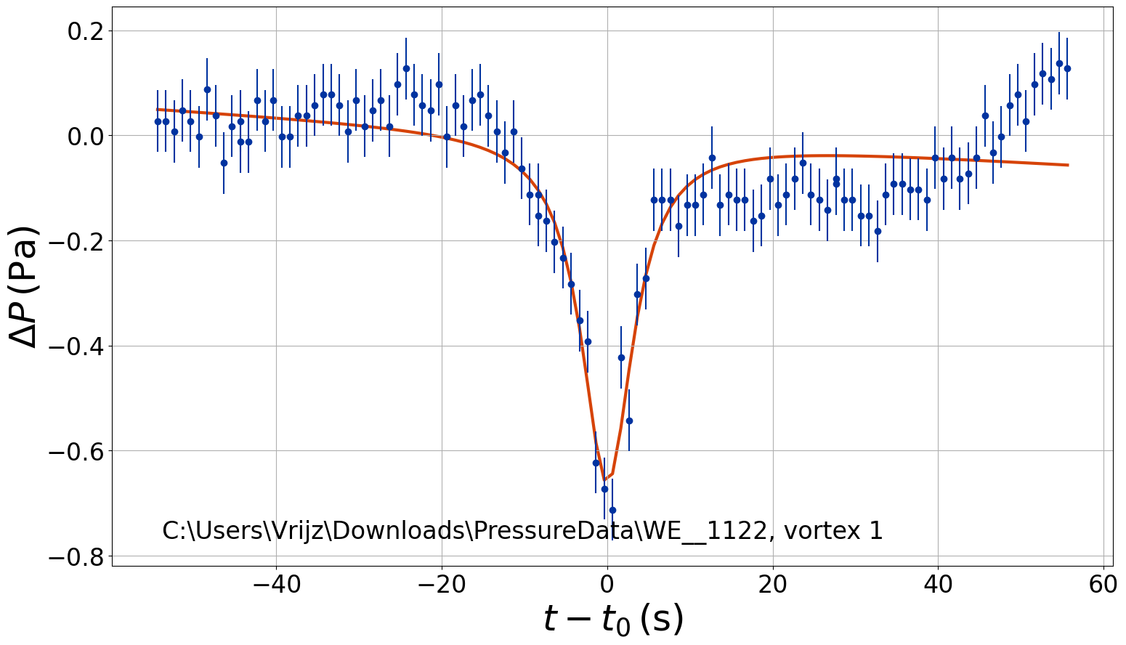
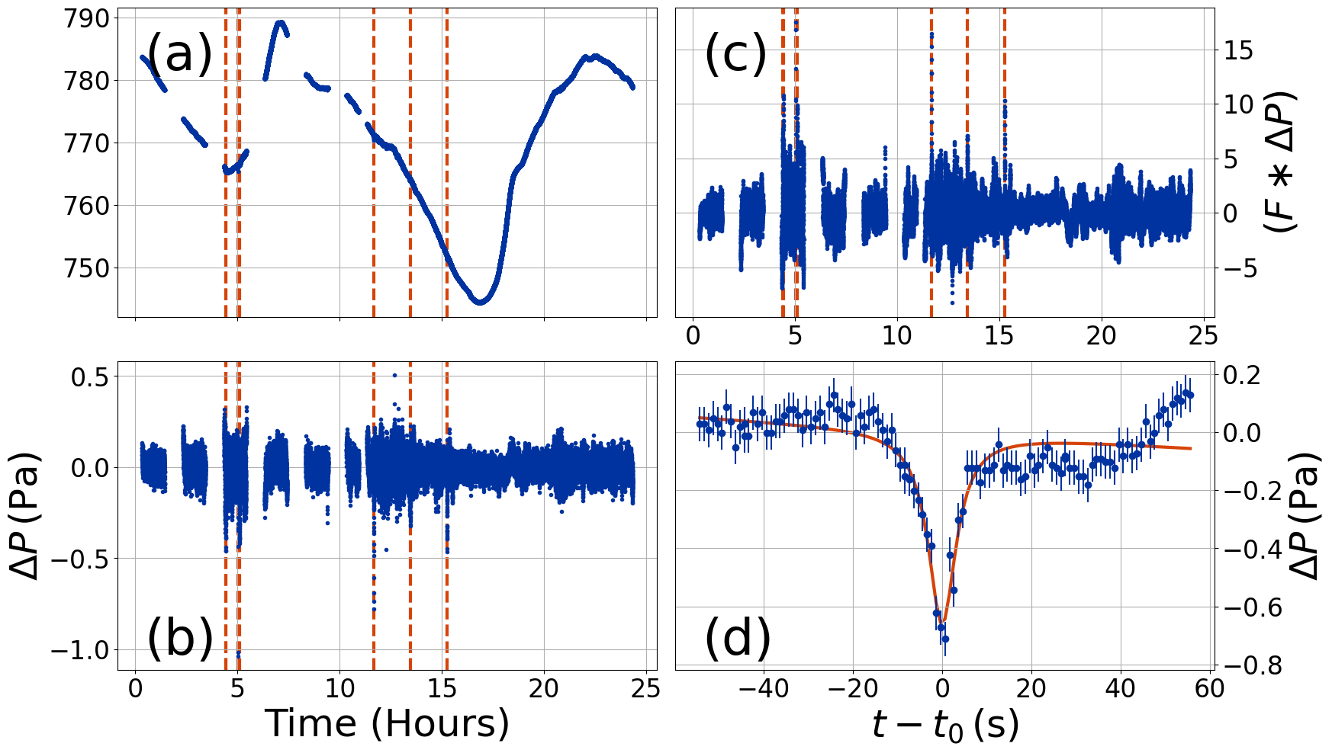

Sol 420
- 4 Vortices
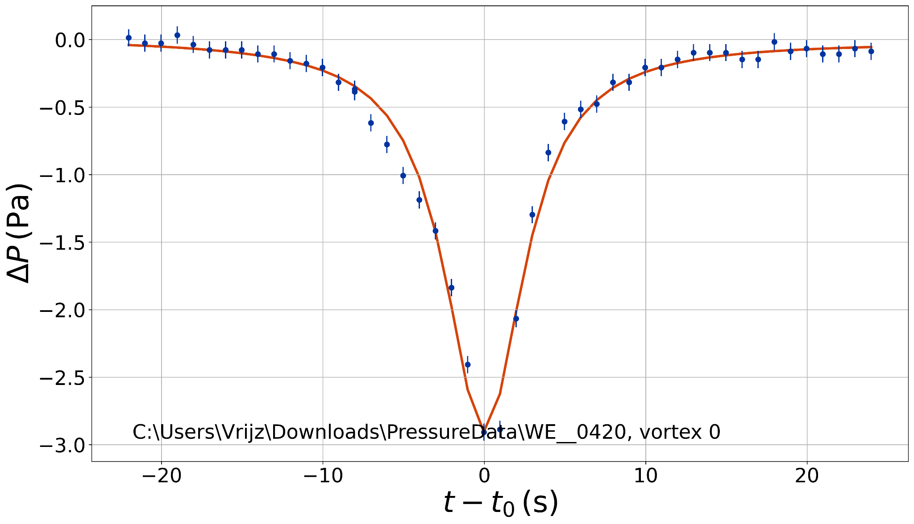
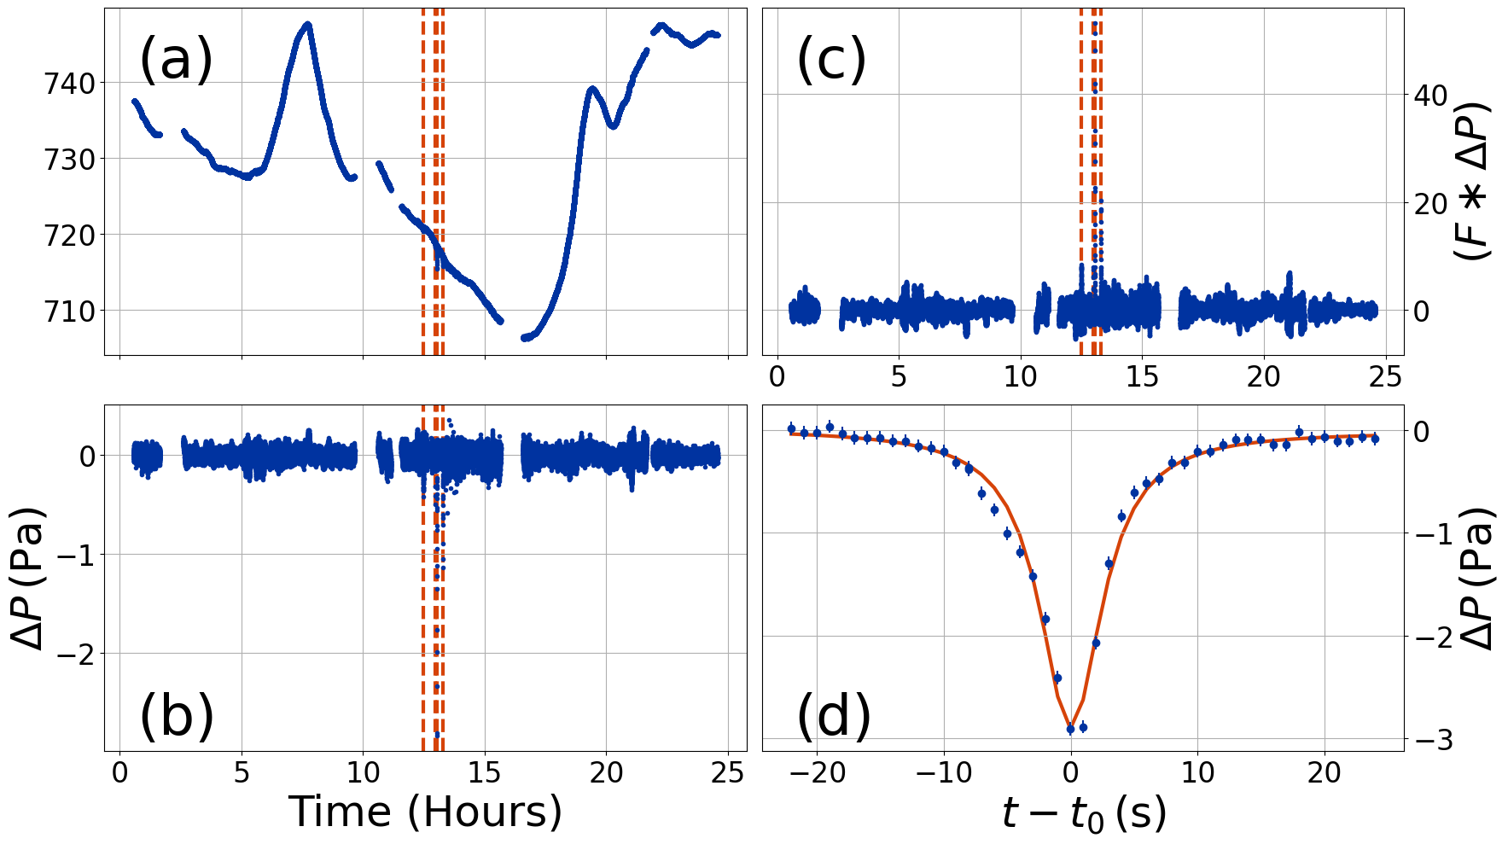
Sol 104
Six vortices, first vortex could not be fit. Very messy data
